**KRSS PAC MEETING**

**Minutes**

**Nov 12, 2024**

**1. Attendance:**

**- Crystal Stankevich, Jennifer Felitsyn, Sandra Hansen, Emily Acton, Greg Wanke, Sue hopkins, Jen Huscroft, Student Rep. Hyaa Qazi, Athletic Director Josh Nicol, Principal Darryl Adams, and Vice Principal Mike Nelson**

**2. Meeting called to order at 9:05 a.m.**

**3. Approval of Agenda Jen H(m), Sue H (s), carried/Minutes of Oct 8, 2024 Jen H(m), Emily(s), carried**

**4. Student Representative - Hyaa**

**There will be a Winter Dance Dec 6/24. The group is looking for parent chaperones to help out from 6-10pm. Crystal will put an email together for parent distribution. As well they are asking for assistance having some snacks served from the concession area. Jen Felitsyn will coordinate with Hyaa. They are also asking for funds to support the snacks. A motion to fund up to $200 from the gaming account is made. Jen F(m), Jen H (s), carried.**

**5. Discussion Items (Josh Nicol)**

* **In the last Downtown Revitalization Plan, the Town of Creston has several proposals involving changing the highway. All of the proposed plans would involve a change in the outdoor space at KRSS.** [**Downtown Revitalization Plan | Town of Creston**](https://www.creston.ca/downtown-revitalization-plan) **It will be important to monitor the plans going forward and advocate for KRSS space/use in this process.**
* **Athletic communication is mostly occurring via the Athletic website. Parent expressed concern with how information is shared to families. Often the information is shared with the team from the coach and then to home. Is there a more effective way? Perhaps a parent coordinator for the teams would be able to assist coaches in communication and organization.**
* **Funding Request - There has been a change in the game ball used for basketball and volleyball. The school requires 12 basketballs and 12 volleyballs. A motion is made to fund the purchase of these game balls from the gaming account of $1854.27. Greg (m), Emily (s), carried**

**6. Treasurer’s Report**

**- General Account $1355.91 ($958.45 available for regular spending, the rest is earmarked for breakfast/lunch programming)**

**- Gaming $20,225.07 (This year’s grant of $11,620.00 was deposited.)**

**- Motion to accept the treasurer’s report. Emily (M), Sandra (S), carried.**

**6. Principal’s Report - Darryl Adams**

* **Today marks the beginning of Term 2 for our students. The majority of students will have the exact same course load as first term, with the exception of the Grade 8s who will have one different elective in their elective exploration block. Teachers will be busy writing Learning Updates over the next couple of weeks, with our first learning update being published on Friday November 22 nd .**
* **12 KRSS students participated in the SD 8 Student Leadership Conference at Mt. Sentinel Secondary School on Tuesday Nov. 5 th . The students who represented KRSS were 10 members of our Student Council ranging from grade 8-12 and our 2 student trustees. The theme this year was “Future Ready” with the keynote speaker being from Selkirk College and opening dialogue with the students around A.I. and possible future impacts of AI.**
* **Near the end of October, we hosted our first sitting of the Numeracy and Literacy Grad Assessments. Students in Grades 10-12 will have 4 different opportunities to write the assessments this year and will need to complete the Numeracy 10 and Literacy 10 and 12 assessments prior to Graduation. Students have an opportunity to re-write assessment if they choose, and parents can learn more about the three-year graduation plan and scholarship opportunities at the SD 8 parent engagement night on Thursday November 28 th at 7:00pm**
* **KRSS hosted their annual Remembrance Day Assembly on Friday November 8 th . Thanks to Ms. Falck and her CLC 12 class for creating and leading the assembly. The students were well prepared, and the student body was respectful and attentive throughout the duration of the service.**
* **Lastly, thanks to our PAC for hosting the Hot Dog Lunch on Monday Oct. 28 th . I believe somewhere around 10,000 hotdogs were consumed by our student body (actual number around 400!) and we thank you greatly for your time and efforts in creating a welcoming environment for all our students.**
* **Mr Nelson added that we are still in communication with the organization doing a pilot program of the School Messenger App. We have asked to be part of that pilot.**

**7. Discussion Items**

* **Volunteers must complete a volunteer package every year. This includes getting a Criminal Record Check yearly. The forms are repetitive and the PAC is wondering if they could be updated to streamline the process.**
* **A funding request has been put forward for an ice machine to be installed in the new kitchen. This will support the need for ice packs during extracurricular events and daily student needs. A motion is made to fund $544.31 from the gaming account for this purchase. Jen F(m), Greg (s), carried.**
* **The Prom Committee is asking for support from the PAC. This has been an event that PAC helps to fund every year. A motion is made to fund up to $1500.00 from the gaming account for the Prom event. Jen H (m), Sue(s), carried.**
* **Food Programming - the PAC continues to support the lunch program with volunteers. A school wide soup day will take Nov 29. As Nov is Metis awareness month, Crystal will coordinate with the ABED department to prepare a soup. Dec 20 the leadership class is putting on a winter carnival. They are asking for assistance. Pac will support with the Hot dog lunch.**
* **Jen F. would like to coordinate a popcorn sale. She needs to purchase some popcorn and then will set a date and time. A motion is made to purchase popcorn from the general account in the amount of $64.98. Jen H(m), Sue (s), carried.**
* **The recycling/returnables have not been collected by the group from school. Jen will arrange to pick them up and get them returned.**
* **Would there be a way that PAc could host an event that would foster the communication and relationships with the staff at KRSS? Something to think on and revisit.**
* **Darryl has emailed the district to follow up on where KRSS is on the facilities paving list. He is also getting clarification regarding rentals during the school closures.**
* **Organizational Chart of SD8 shared** 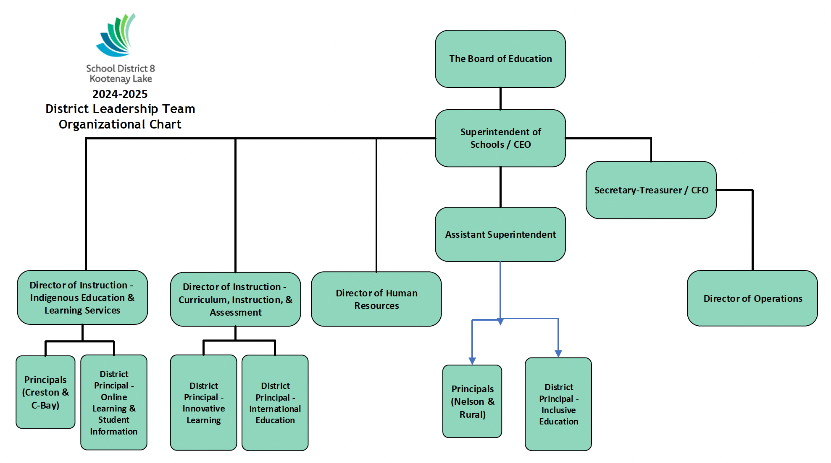

**8. Call for nominations for Secretary…. None at this time. Revisit next meeting**

**9. Open Floor**

* **Parent member asked if there was any movement or update on Academic Acknowledgement for KRSS. At this time a teacher would have to take this on and organize it. There is no way of generating an “honors” list with the current reporting software.**

**Next Meeting Dec 10 at 9 am.**